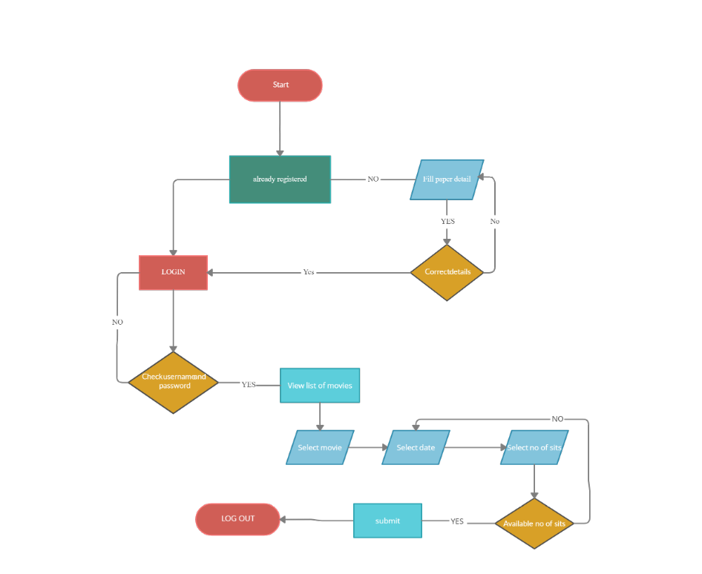

**Tabel cu useri**

**Tabel cu lista filmelor**

**Tabel cu lista rezervarilor**

Movie list

movie_id(PK) int

movieName String

movieType String

roomNumber int

User

User_id (PK) int

firstName String

lastName String

e-mail String

Movie reservation

movie_id(FK) int

movieName String

movieDate Datetime

sitsNumber int

reservationNumber int

user_id(FK) int

M

1

M

1

M

Login/create user

e-mail

Password

User_id(FK)

1

Exceptions

**loginException**

getMessage() – no duplicate

**missingExeption**

getMessage()

User

UserId

firstName

lastName

e-mail

create Account()

logIn()

viewListMovie()

makeReservation()

selectSits()

submit()

logout()

MovieRepository

findbyID()

findAll()

findbyName()

save()

delete()

MovieList

movieID

movieName

movieType -enum

viewListMovie()

User Repository

findbyID()

findAll()

findbyName()

save()

delete()